

Student Name
Yang Liu
Student Number
230482
Module Title
Strategic Thinking
Assessment Title
Data-Driven Daily Operations: Predictive Analytics for Labor Optimization in Hospitality Industry

Lecturer/Supervisor
Taufique Ahmed
Assessment Due Date
25/10/2026
Date of Submission
22 /10 /2026

Abstract

Labour is undoubtedly the largest controllable expense in the hospitality industry. However, when tourist numbers fluctuate from day to day, tourist attractions often struggle to get their staffing levels right. This usually results in either staff shortages that cause long waiting times and complaints, or overstaffing that wastes payroll budget.
This project investigates labour optimization by developing a predictive staffing model for a real tourist attraction in Ireland. Using an anonymized dataset of daily operational records covering January 2024 to September 2026, the project will use Python to clean the data, find historical patterns, and build machine learning models to forecast future daily traffic. The final deliverables will include a clear visitor-to-staff ratio matrix and an interactive dashboard for stakeholders.
Ultimately, this project aims to turn messy operational data into a practical business solution, helping management schedule the ideal number of staff needed to improve customer satisfaction and maintain profitability.

Contents
1. Project Title 1
2. Introduction 1
3. Problem Definition 1
4. Aim and Objectives 1
4.1 Data Preparation 2
4.2 Demand Analysis & Predictive Modelling 2
4.3 Optimal Visitor-Staff Ratio 2
5. Scope 2
5.1 Semester 1: Data Preparation and Exploratory Data Analysis (EDA) 2
5.2 Semester 2: Predictive Modelling and Data Visualization 2
6. Methodology 2
6.1 Overall Plan 2
6.2 Tools and Methods 3
6.3 Overall Workflow 3
7. Data Sources 3
7.1 Data Sources and Type 3
7.2 Approximate Amount of Data 3
7.3 Relevance to the Business Problem 3
7.4 Data Access and Ethical Permissions 3
8. Expected Deliverables 4
8.1 Data Analysis Report 4
8.2 Predictive Model 4
8.3 Interactive Dashboard 4
9. Project Timeline 4
9.1 Overall Timeline 4
9.2 Project Gantt Timeline 5
10. Ethical and Legal Considerations 5
10.1 Data Privacy (GDPR) 5
10.2 Permissions 5
10.3 Security 5
References 6

Capstone Project Proposal
Github: https://github.com/DannieYL/230482-YangLiu-StrategicThinking-CA1

1. Project Title
Data-Driven Daily Operations: Predictive Analytics for Labour Optimization in Hospitality Industry

2. Introduction
By the end of 2025, the Irish tourism industry employed 226,800 people and was the largest indigenous sectoral employer in regional Ireland, according to the Irish Tourism Industry Confederation (2025), which also predicted a growth of 5% to 7% in tourism revenue for 2026.The global tourism and hospitality industry relies heavily on human interactions as labour is undoubtedly recognized as the largest controllable expense in the hospitality industry. This project is an initiative to investigate the labour optimization in tourism as well as using predictive modelling to forecast future daily operational flow for a tourist attraction in Ireland.
I choose this dataset because I have related work experiences in such industries and by observing the daily operational figures, I have always wanted to explore the business insights behind the numbers. This project is an excellent example of data analysis practice as it aims to combine the human element and the problem-solving aspects in a business context which will align labour deployment precisely with demand to enhance overall customer experience.

3. Problem Definition
According to Epos Now (2026), the gap between guest expectations and reduced staffing levels is a major challenge for the industry. As a result of these shortages, there are persistent complaints regarding the overall guest experience, specifically concerning extended wait times and poor on-site traffic management. This project displays the daily operational dataset of a tourist attraction which requires a better allocation of its staff members in different functional sectors for varied days of the week. By identifying historical patterns and forecasting visitor demand, this project provides management with precise staffing recommendations. The goal is to improve customer satisfaction through better resource allocation while maintaining profitability.

4. Aim and Objectives
The objective is to provide data-driven recommendations for a predictive scheduling framework by developing a predictive staffing model that helps management schedule the ideal number of staff. Developing a machine learning-based predictive staffing model will significantly reduce the variance between scheduled labour hours and actual visitor footfall compared to static scheduling practices.
To achieve this aim, this project will focus on the following main achievable objectives:

4.1 Data Preparation
Clean and standardize the operational dataset—including null values, staff numbers, and temporal factors for analysis.

4.2 Demand Analysis & Predictive Modelling
Use EDA to identify key demand factors and build a predictive model to forecast daily traffic, eliminating both overstaffing and understaffing.

4.3 Optimal Visitor-Staff Ratio
Analyze visitor volumes and historical staffing to define a clear ratio matrix that minimizes tourists’ waiting times while strictly controlling labour costs.

5. Scope
To achieve sufficient scope for investigation and development across two semesters, the project will follow these areas:

5.1 Semester 1: Data Preparation and Exploratory Data Analysis (EDA)
- Transforming messy data into a clean, structured format suitable for analysis or machine learning using tools such as Python.
- Investigating the dataset to summarize its main characteristics, find patterns and check assumptions using statistics tools like relevant descriptive statistics and appropriate plots for critical analysis.

5.2 Semester 2: Predictive Modelling and Data Visualization
- Training and testing predictive machine learning models to forecast daily operational demand.
- Develop the optimal visitor-to-staff ratio matrix for key functional sectors.
- Deliver a final data model for labour Optimization and Visualization.
- Provide business insight on the marketing strategy based on the model.
And the following areas will be excluded from this project:
- External and Environmental factors: this project will not investigate external factors such as daily weather conditions, promotional events.
- Ticket pricing and revenue management: this project will not focus on maximizing revenue by adapting ticketing pricing strategies.
- Retail inventory management: this project will solely evaluate human resource deployment, any retail inventory, supply chain related factors are excluded.

6. Methodology

6.1 Overall Plan
As the dataset has been masked and scaled from the original data, we will first clean the raw dataset to fix any missing or messy values, then we will read and understand the dataset based on its statistical features which helps us to find the data patterns using analytical tools. We will use machine learning models for predictive modelling on predicting future data and use visualization tool for final business insights.

6.2 Tools and Methods
- Python: The main programming language.
- Pandas, NumPy, Seaborn: The main data libraries used to clean, organize and visualize the dataset.
- Scikit-learn: The main Machine Learning tool to test predictive models.
- Matplotlib/Power BI/Tableau: The main visualization tool for charts, reports and dashboards.

6.3 Overall Workflow

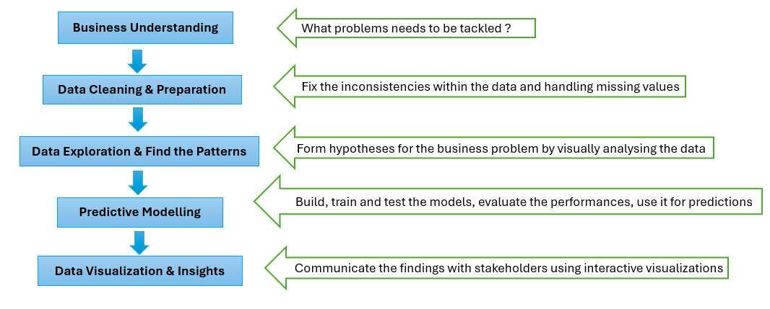

7. Data Sources

7.1 Data Sources and Type
This project uses synthetic data based on a real tourist attraction. The original dataset was masked and scaled to protect confidential business information.

7.2 Approximate Amount of Data
The dataset includes 1000 rows of daily operational records (representing period from 1st of January 2024 to 26th September 2026 of continuous data) structured across 11 specific feature columns.

7.3 Relevance to the Business Problem
By linking daily ticket sales and dates to daily staffing levels, this dataset helps the model predict future staffing demand.

7.4 Data Access and Ethical Permissions
This internally sourced dataset is completely anonymized and aggregated daily to comply with GDPR and academic integrity standards. It contains strictly quantitative data with no Personally Identifiable Information for visitors or staff, ensuring all ethical and legal research requirements are met.

8. Expected Deliverables

8.1 Data Analysis Report
A clear summary of the dataset and how specific factors impact the overall performance.

8.2 Predictive Model
A trained and tested machine learning model built in Python that can predict future daily tourist numbers based on the historical data.

8.3 Interactive Dashboard
An interactive dashboard where different functional sectors of stakeholders can easily access and understand the overall tourists and staffing figures for future resource allocation strategy.

9. Project Timeline

9.1 Overall Timeline

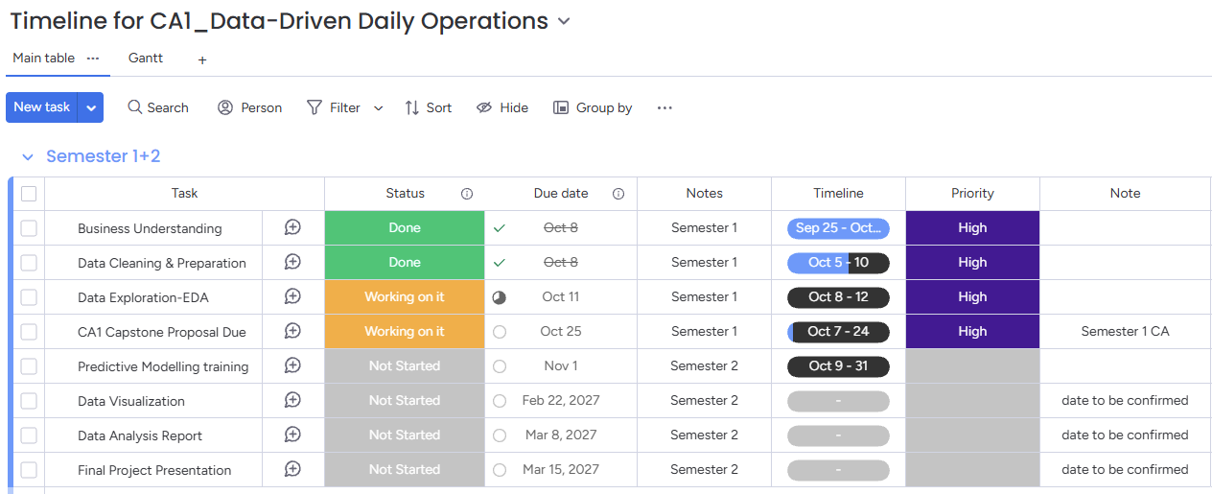
(Project Timeline)

9.2 Project Gantt Timeline

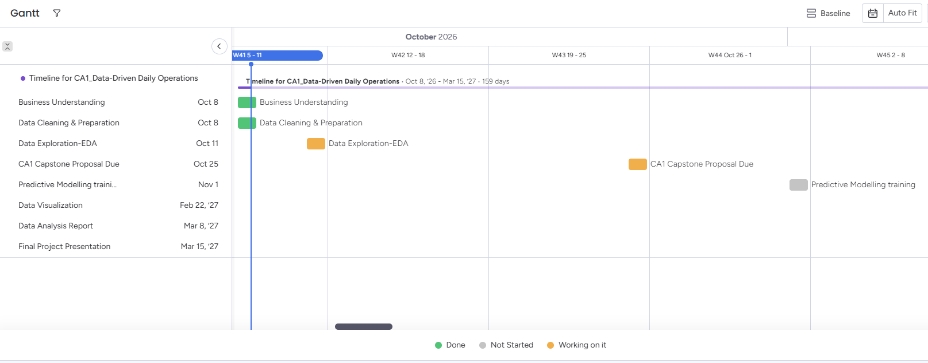
(Gantt Timeline)

10. Ethical and Legal Considerations
The dataset utilized for this analysis consists of simulated and anonymized operational time-series records representing visitor footfall, ticket revenue streams, and staffing allocations across six core operational departments. All metrics have been aggregated and masked to ensure no personal or commercially confidential proprietary data is disclosed, complying fully with academic research integrity standards and the provisions of the General Data Protection Regulation (European Union, 2016).

10.1 Data Privacy (GDPR)
The dataset contains no personal information. It uses total daily numbers, meaning no names, IDs, performance or financial details related to staff are included.

10.2 Permissions
This dataset has been masked and scaled to protect confidential business information.

10.3 Security
All data will be kept on a password-protected computer and permanently deleted once the course is finished.

References

Epos Now (2026) Labor Shortage in Hospitality Industry: Addressing Challenges. Available at: https://www.eposnow.com/us/resources/labor-shortage-in-hospitality-industry/ (Accessed: 22 October 2026).
European Union (2016) Regulation (EU) 2016/679 of the European Parliament and of the Council of 27 April 2016 on the protection of natural persons with regard to the processing of personal data and on the free movement of such data, and repealing Directive 95/46/EC (General Data Protection Regulation). Official Journal of the European Union, L 119/1. Available at: https://eur-lex.europa.eu/eli/reg/2016/679/oj (Accessed: 22 October 2026).
Irish Tourism Industry Confederation (2025) Irish Tourism Review 2025 & Outlook 2026. Available at: https://www.itic.ie/ye25-outlook26/ (Accessed: 21 October 2026).

